G1000 Flight Plan Loading Reference (Please use G1000 Manual for full steps):
- Copy .FPL files to the supplemental DB SD card
- Put SD Card in MFD (Right screen) -> Top Slot.
- Go to Flight Plan List Page
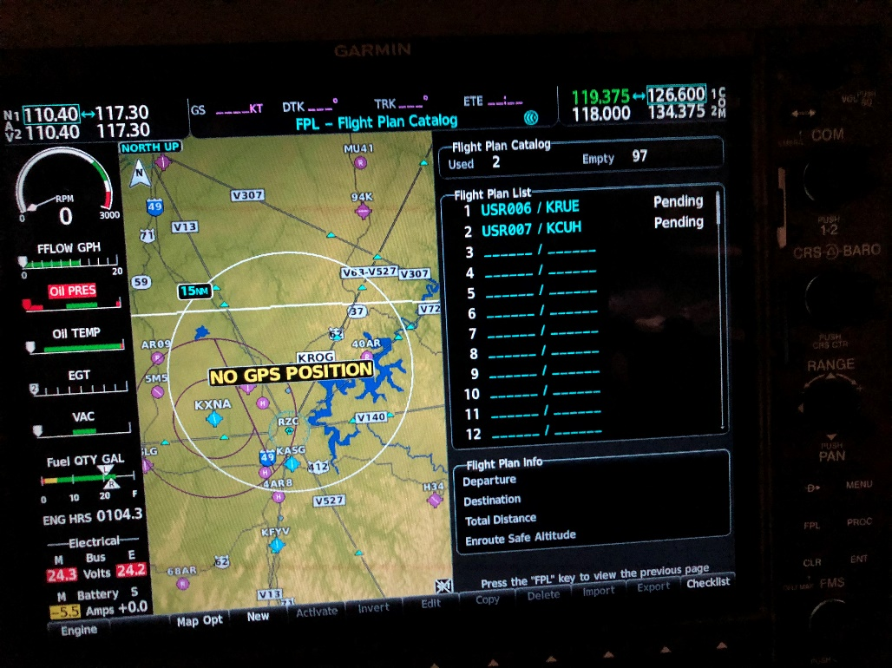
- Turn the cursor on and select a blank flight entry.
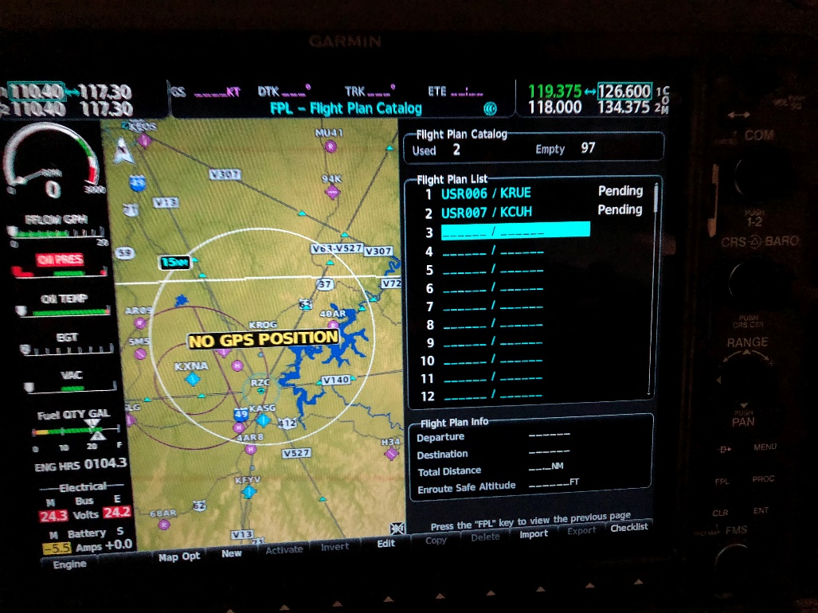

- Press Menu
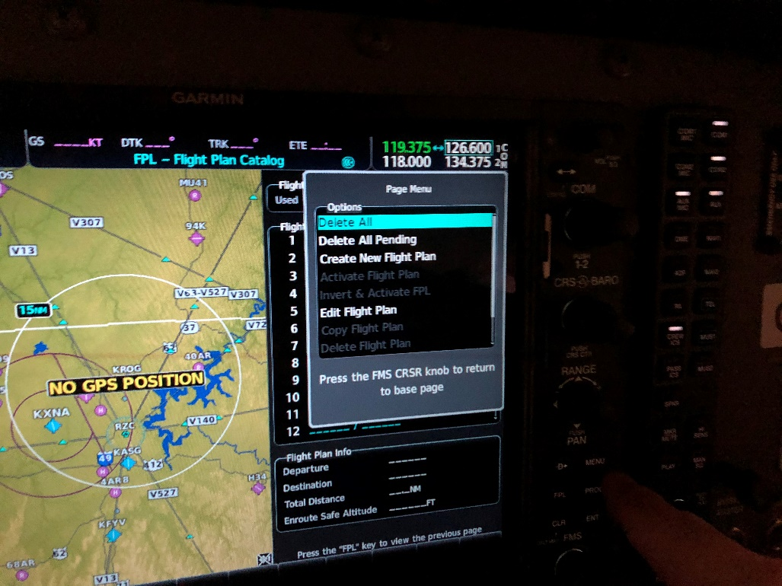

- Scroll Down and select “Import Flight Plan”
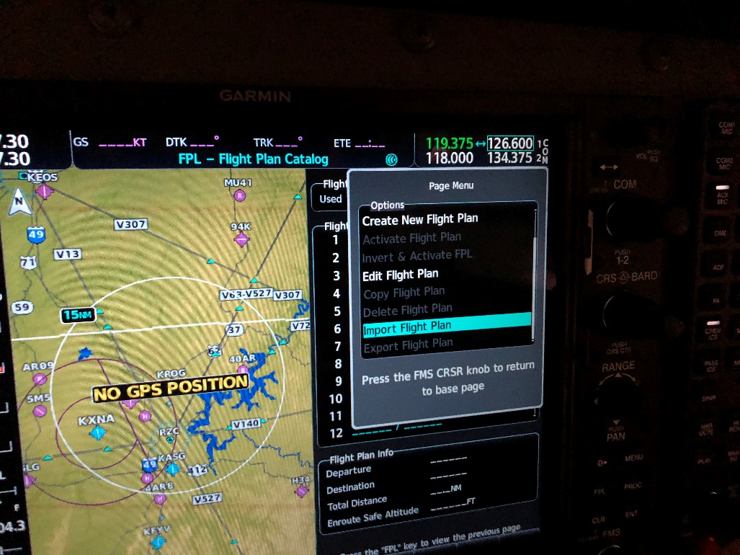

- Select a flight plan to import and press enter.
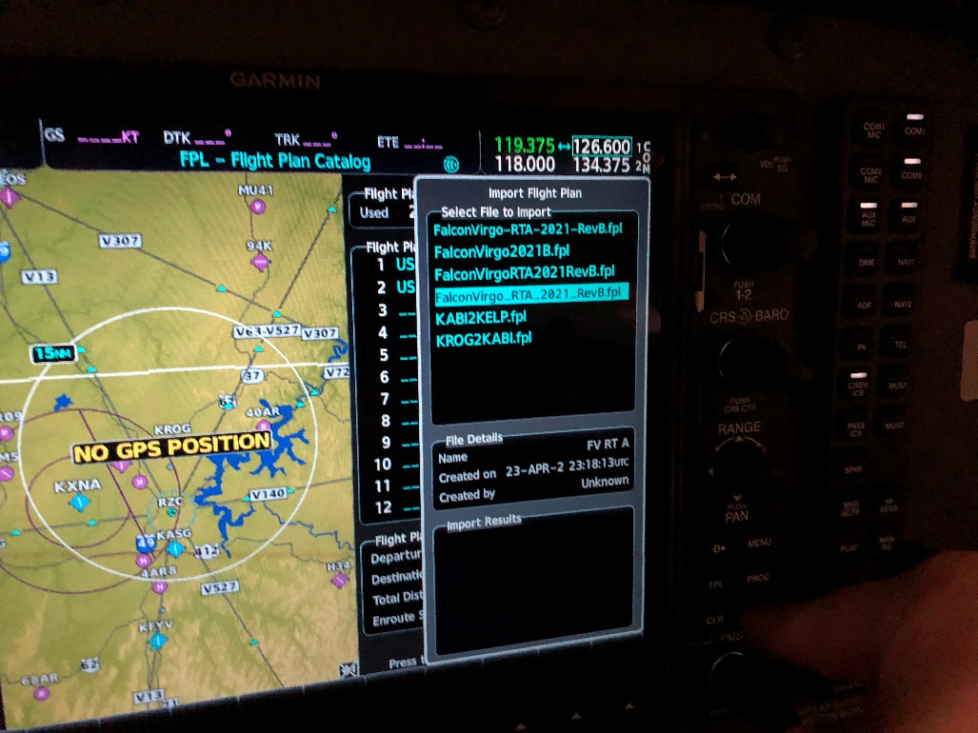
- You should see a successful import message. Press menus to close the screen.
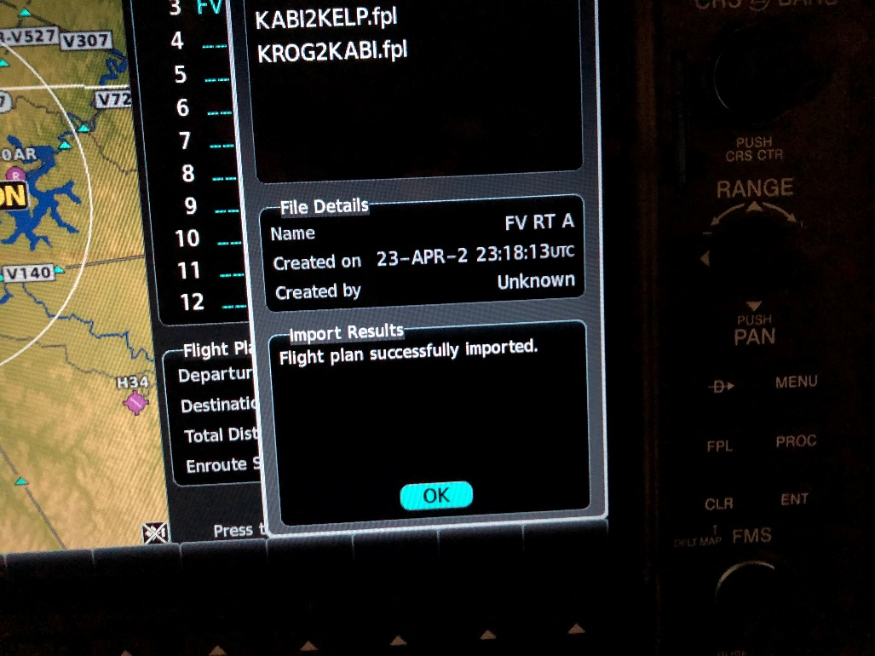

- Now that you have imported the flight plan, you should now see it on the list.
